ASSESSMENT: Linux Basics, System Administration & Storage Management

A Section A — Concept Application

S1. SCENARIO AlphaTech is new to Linux and wants to understand why it is used in enterprise environments.

ANS:

1. History and Evolution of Linux
Linux was created by Linus Torvalds in 1991. He started Linux as a free operating system kernel while he was a student.
Over time, many developers around the world contributed to Linux. It became popular because it is open-source, free, secure, and highly customizable.
Today, Linux is widely used in:
- Servers and data centers
- Cloud computing
- Web hosting
- Cybersecurity
- Supercomputers
- Mobile devices (Android uses the Linux kernel)

2. Difference Between Ubuntu, CentOS, Debian, and RHEL

Linux OS | Simple Explanation
Ubuntu | Beginner-friendly Linux based on Debian. Easy to install and commonly used for desktops, servers, and cloud.
Debian | Very stable and community-driven Linux distribution. It is known for reliability.
CentOS | Historically a free, community version closely related to RHEL. CentOS Linux was discontinued in 2021, and CentOS Stream is now the upstream development version for RHEL.
RHEL | Red Hat Enterprise Linux. A commercial Linux used by businesses because it provides professional support, security, and long-term enterprise features.

3. Why Linux is Preferred Over Windows for Servers
Linux is commonly preferred for servers because:
- Free and open-source – No expensive operating system license is required for many Linux distributions.
- Stable – Linux servers can run for long periods without frequent restarts.
- Secure – Linux provides strong permissions, user management, and security tools.
- Lightweight – It can run efficiently even without a graphical interface.
- Highly customizable – Administrators can install only the software they need.
- Good for automation – Tasks can easily be automated using scripts and tools such as cron.
- Popular in cloud computing – Many cloud servers use Linux.
Example: A company running a web server can use Linux with Apache or Nginx without needing a full desktop environment.

4. When is CLI Better Than GUI?
CLI (Command Line Interface) means managing Linux by typing commands in a terminal.
GUI (Graphical User Interface) means managing the system using windows, buttons, and menus.
For servers, CLI is often better because:
- It uses fewer system resources.
- It works well on remote servers through SSH.
- Commands are faster for experienced administrators.
- Tasks can be automated with scripts.
- It is useful when a server does not have a desktop environment.
- Administrators can manage many servers efficiently.

Example:

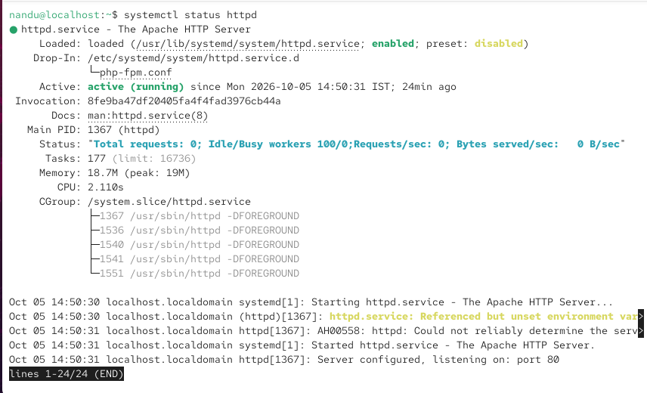

This command checks the status of the Apache web server.

Another example:

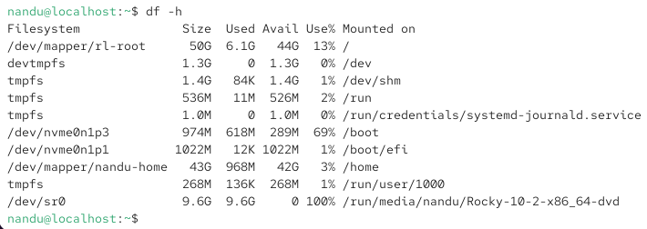

This shows disk space usage.

S2. SCENARIO A junior administrator on AlphaTech's team is learning Linux administration and needs to understand the core file and directory commands.

Question: Explain the purpose of the ls, cd, pwd, mkdir, rm, cp, and mv commands, and describe how each is used in real server management.

ANS:

1. ls – List Files and Directories
Purpose: Shows the files and folders in the current directory.
- ls
Example:

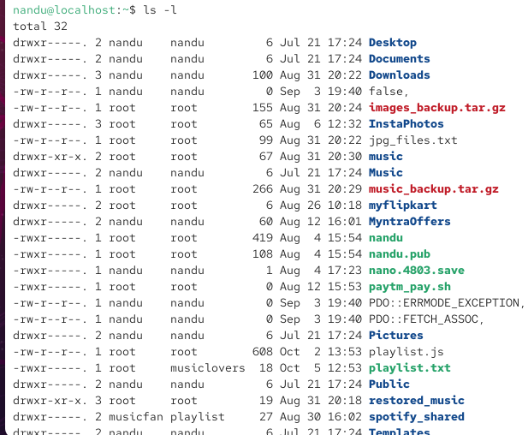

Shows files with details such as permissions, owner, size, and date.
Real server use: An administrator uses ls to check whether a configuration file, log file, or directory exists.

2. cd – Change Directory
Purpose: Moves from one directory to another.
- cd /var/log
Example:

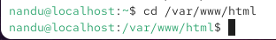

Real server use: An administrator uses cd to move to directories containing website files, logs, configuration files, or backups.

3. pwd – Print Working Directory
Purpose: Shows the current directory path.
- pwd
Example output:

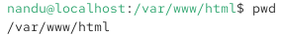

Real server use: It helps administrators confirm where they are before creating, moving, or deleting files. This is especially useful on remote servers.

4. mkdir – Make Directory
Purpose: Creates a new directory.
- mkdir backups
Example:

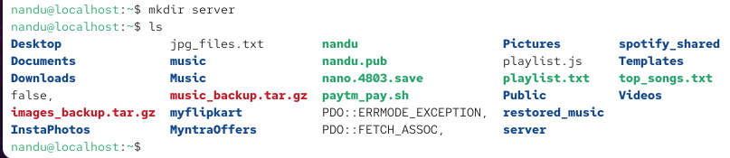

Real server use: Administrators use it to create folders for backups, logs, projects, or application files.

5. rm – Remove Files or Directories
Purpose: Deletes files or directories.
- rm oldfile.txt
To remove an empty directory:
- rmdir folder
To remove a directory and its contents:
- rm -r old_folder
Real server use: Used to remove old files, temporary files, or outdated backups.

6. cp – Copy Files or Directories
Purpose: Creates a copy of a file or directory.
cp file.txt backup.txt
To copy a directory:
cp -r website website_backup
Real server use: Commonly used to create backups before changing configuration files.
Example:
cp /etc/ssh/sshd_config /etc/ssh/sshd_config.backup

7. mv – Move or Rename
Purpose: Moves a file/directory or renames it.
To rename:
mv old.txt new.txt
To move:
mv file.txt /home/user/documents/
Real server use: Administrators use it to organize files, rename configuration files, or move logs and backups.

S3. SCENARIO AlphaTech wants to install its first Linux server using VirtualBox or VMware. Question: Explain the steps to install Ubuntu Server or CentOS, and justify why hostname configuration, static IP configuration, SSH setup during installation, and initial system verification are each important before the server goes live.

ANS:

- Create a Virtual Machine:
Open VirtualBox/VMware and create a new VM. Give it enough RAM, CPU, and disk space.
- Install Linux:
Attach the Ubuntu Server or CentOS ISO file and start the VM. Follow the installation steps and create a user/password.
- Configure Hostname:
Give the server a unique name, such as alphatech-server.
- Configure Static IP:
Set a fixed IP address, gateway, and DNS.
- Enable SSH:
Install/enable the SSH service during installation.
- Initial Verification:
Check the hostname, IP address, internet connection, disk space, and SSH connection.

S4. SCENARIO Multiple employees will need access to the AlphaTech Linux server. Question: Explain how Linux users and groups work, the difference between user and group permissions, how useradd, groupadd, and passwd are used to manage them, and why user isolation matters on a multi-user system.

ANS:

- Users: Each employee gets their own Linux account. This keeps their files and access separate.
- Groups: A group is used to give the same access to multiple users, such as an IT group.
- User permissions: Decide what a particular user can read, write, or execute.
- Group permissions: Decide what members of a particular group can access.

Common Commands
- useradd username → Creates a new user.
- groupadd groupname → Creates a new group.
- passwd username → Sets or changes the user's password.

Why user isolation matters:
Each employee should only access the files and resources they need. This protects data, prevents accidental changes, and improves server security.

S5. SCENARIO A developer on the team asks where system files and user files are stored on the server. Question: Explain the purpose of the /, /etc, /var, and /home directories, and justify why the Linux directory structure separates files the way it does in server environments.

ANS:

- / (Root): The main directory. All other directories are inside it.
- /etc: Contains system configuration files, such as network and service settings.
- /var: Stores changing data such as logs, cache, and application data.
- /home: Contains personal files and folders of normal users.

Why this separation is important:
It keeps system files, user files, configuration, and changing data organized. This makes the server easier to manage, troubleshoot, back up, and secure.

S6. SCENARIO AlphaTech needs storage that can grow without downtime as the company scales. Question: Explain what LVM is, its core components (Physical Volume, Volume Group, Logical Volume), its advantages over traditional partitioning, and typical use cases in production servers.

ANS:

LVM is a Linux storage system that makes it easier to manage and increase disk space.
- Physical Volume (PV): The actual disk or partition used by LVM.
- Volume Group (VG): A storage pool made by combining one or more PVs.
- Logical Volume (LV): A virtual partition created from the VG where files are stored.
Advantages of LVM
- Storage can be increased easily when needed.
- Disks can be managed without changing traditional partitions.
- Storage can be resized more flexibly.
- It can help avoid downtime when expanding storage.
Production Uses
LVM is commonly used for database servers, application servers, file servers, and servers where storage requirements may grow.

Section B — Practical Server Administration Tasks

Task 1Linux Installation, Hostname & Core Commands Install a Linux server and verify basic connectivity while practicing core file-navigation commands. (Foundational — single concept, direct implementation.)
- Install Linux (Ubuntu Server or CentOS) on VirtualBox/VMware and set the hostname to alphatech-server.
- Configure a static IP address and enable the SSH service.
- Verify system connectivity after setup.
- Use ls, mkdir, cp, mv, and rm to list /etc contents, create /testdir, and copy, move/rename, and delete test files.

ANS:
Set the hostname AND CONFIGURE A STATIC IP

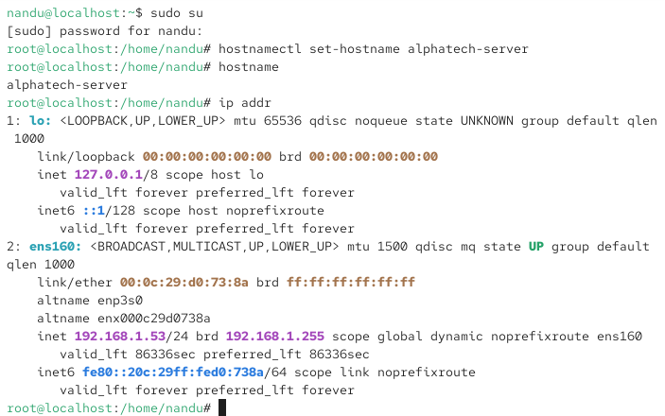
Enable SSH service

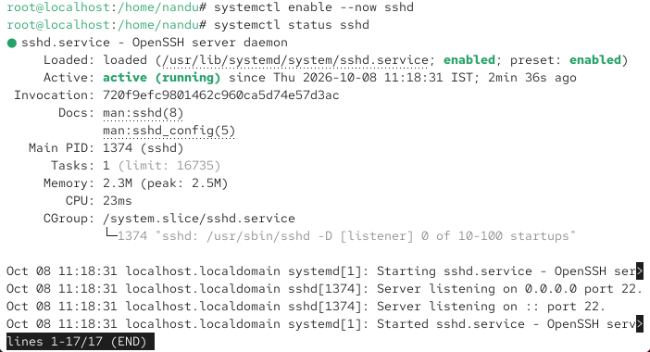

Listed the contents of /etc

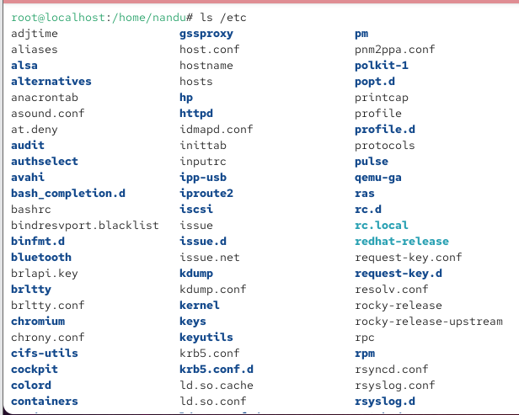

Created a test directory and created a test file and copied it, Moved and renamed the file and delete the test file and verified the directory after deletion using

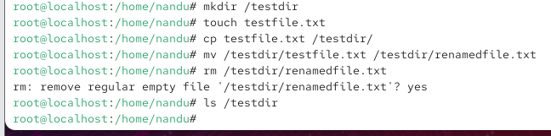

Task 2: User & Group Management
Set up isolated user accounts and a shared group for the development team. (Applied — one concept combined with multiple accounts and conditions.)
- Create group devteam.
- Create users dev1 and dev2 and set a password for each.
- Add both users to the devteam group.
- Verify group membership for both users.

ANS:

Create the devteam group, Create users dev1 and dev2, Set a password for both users, Add both users to the devteam group, Verify group membership for both users
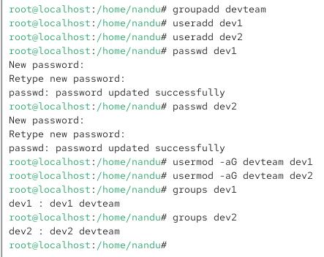

Task 3: File System Permissions & Network Configuration

Secure a project directory with layered permissions and links, then configure and verify network access. (Intermediate — two concepts used together.)

- Create /project with subdirectories /project/docs and /project/scripts, and set ownership to dev1:devteam.
- Set permissions so the owner has full access, the group has read & execute, and others have no access; create and verify one symbolic link and one hard link.
- Configure a static IP, gateway, and DNS, then verify connectivity using ip addr, ip route, and ping google.com.
- Confirm the hostname configuration is correct.

ANS: Create the project directories , set ownership and permission

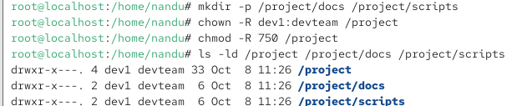

Verified the permissions and Create and verify one symbolic link and also create and check hardlink

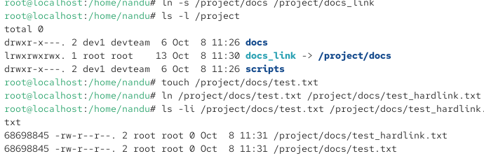

Configure and verify network settings

Checked the IP address using and checked the default gateway using:

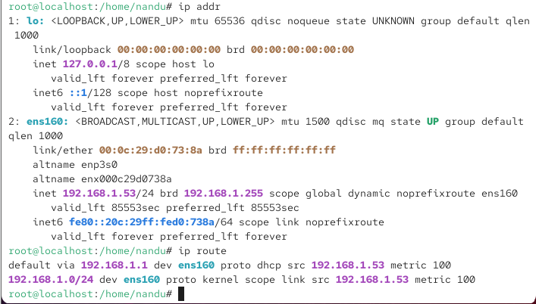

Tested internet connectivity using:

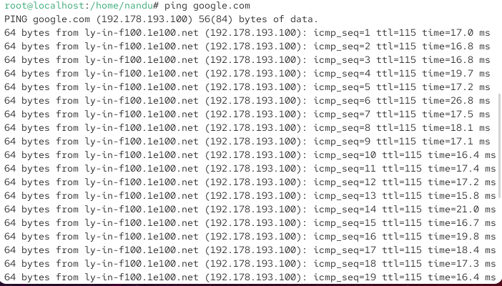

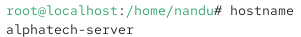

Task 4: LVM Storage Configuration & System Verification

Build flexible storage using LVM and confirm the entire server setup is production-ready. (Integrative — multi-step flow combining 2+ concepts.)

- Create a Physical Volume, Volume Group, and Logical Volume, then format the LV with ext4 or xfs and mount it to /data.
- Verify storage usage and extend the logical volume if space is available.
- Verify that users were created correctly, the network is working, SSH is accessible, and storage is mounted.
- Confirm that all permissions configured in Task 3 were applied correctly.

ANS:

Check available disks

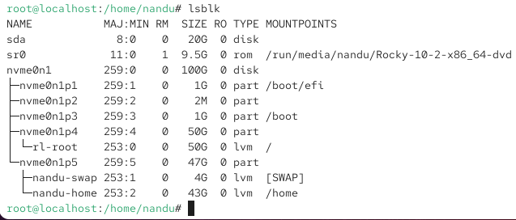

Created and verified a Physical Volume

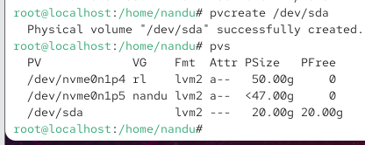

Created and verified a Volume Group

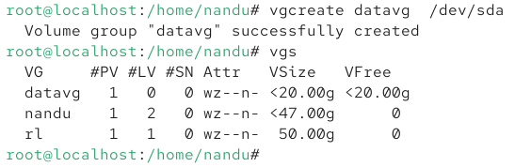

Created and verified a Logical Volume

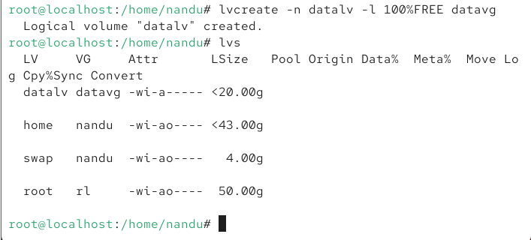

Format and Mount the Logical Volume

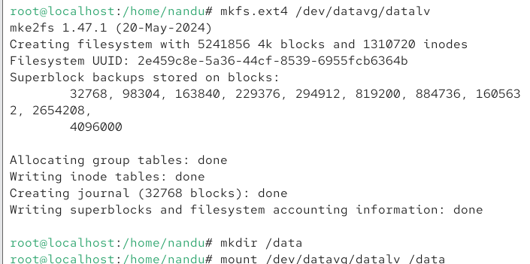

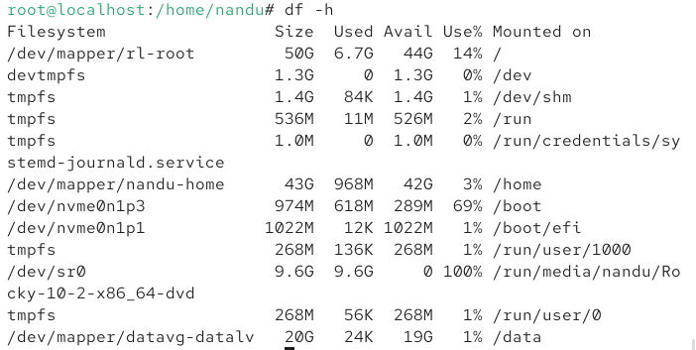

Verify that users were created

Verify the network is working

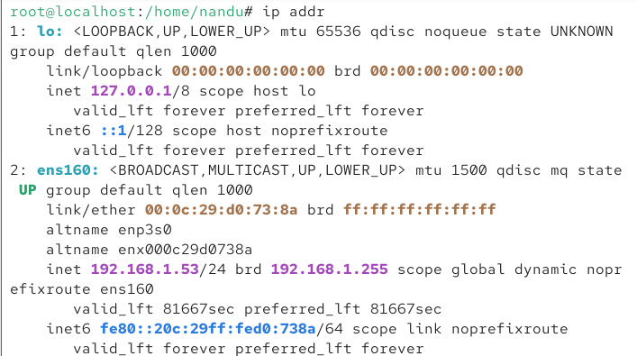

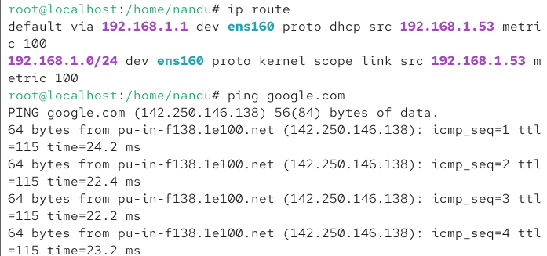

Verify SSH

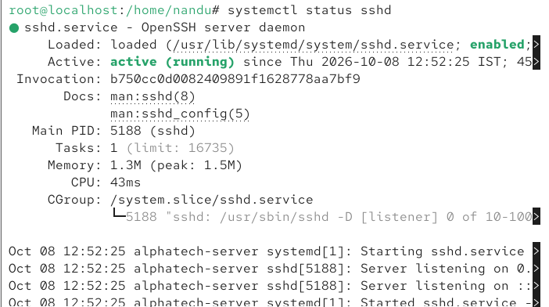

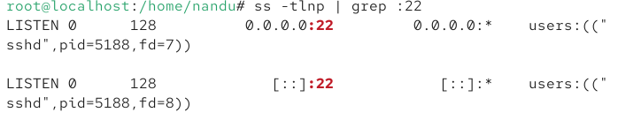

Verify storage is mounted

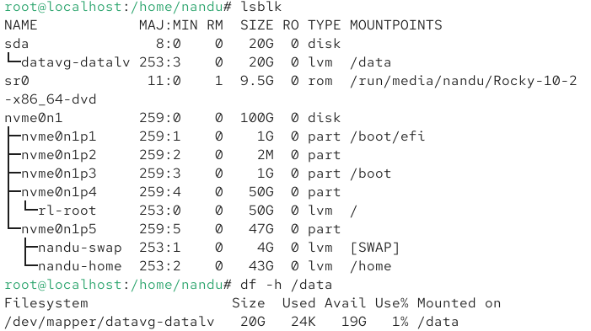

Confirm Task 3 Permissions

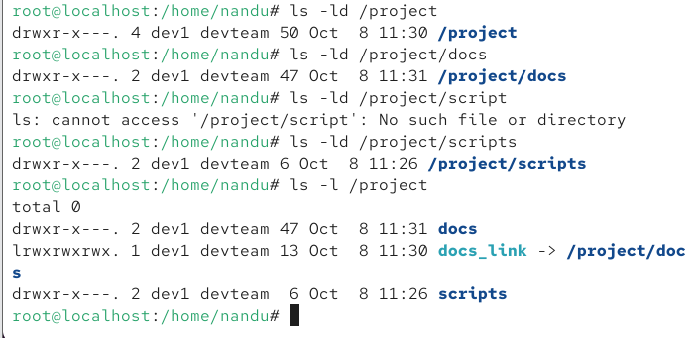

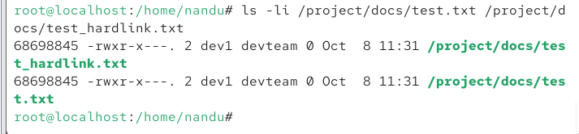

Section C — Mini Capstone Project

Mini Project: AlphaTech Server Recovery & Troubleshooting

Objective:
Troubleshoot and resolve a multi-issue production incident on the AlphaTech server — combining SSH service recovery, file permission repair, LVM storage extension, network diagnostics, and user account validation — into a single documented recovery process.

Your project must:
- Diagnose and fix SSH failing to start after reboot: check service status, restart the service, and enable it at boot.
- Resolve a Permission Denied error on /project by checking and correcting ownership and permissions, then validating access.
- Resolve a disk that is 100% full by checking usage and using LVM to extend storage without downtime.
- Diagnose a server that cannot reach the internet by checking IP configuration, DNS settings, gateway, and connectivity.
- Resolve new users being unable to log in by verifying user creation, password status, and group membership.

ANS:
Check the service status

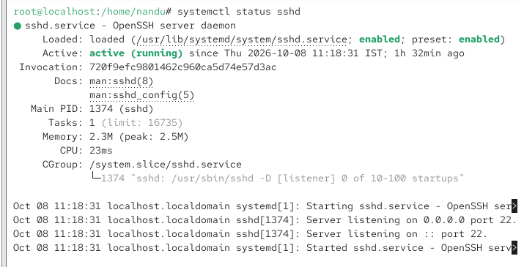

Restart the service
If the service was stopped or failed, I restarted it then I enabled SSH so that it starts automatically after reboot:

Verified the service
Now, the SSH service shows as active (running).

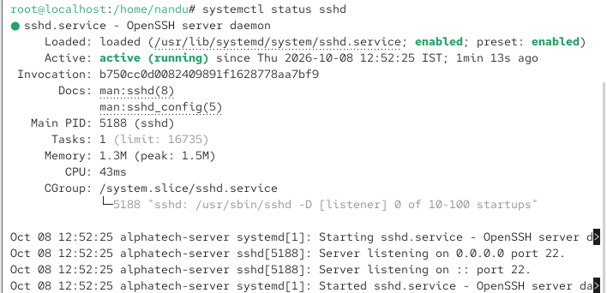

Fix Permission Denied on /project

Checked the ownership and permissions of the project directory

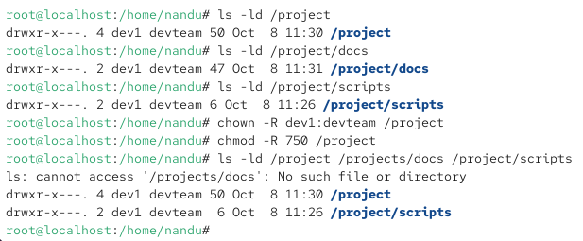

Troubleshoot 100% Full Disk

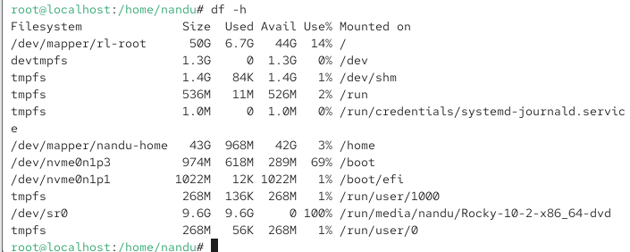

Checked the LVM configuration

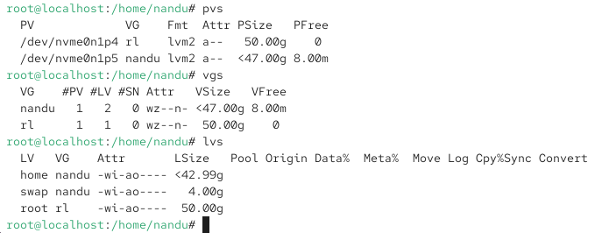

Extend the Logical Volume

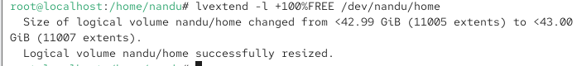

Extend the ext4 Filesystem

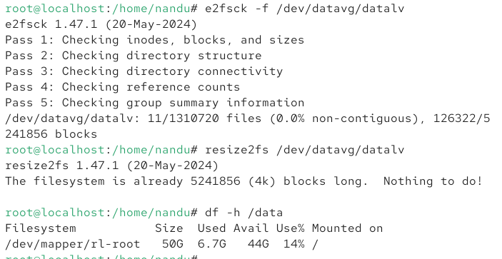

Verify network interfaces

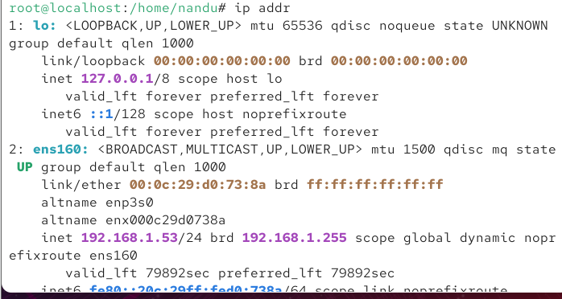

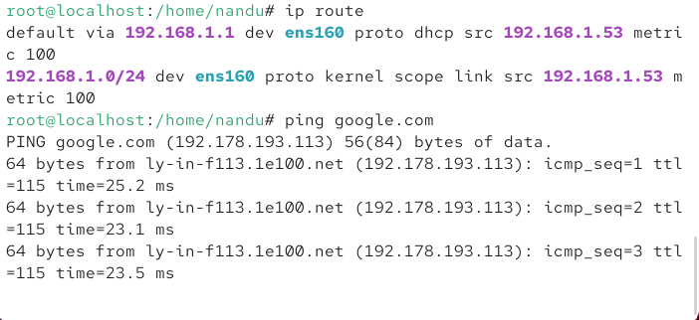

User Account Validation

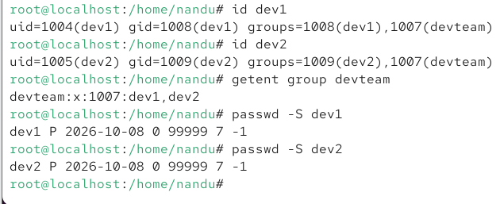

D Section D — AI-Augmented Learning

STEP 1 · BUILD WITH AI
Use an AI tool of your choice (ChatGPT, Claude, GitHub Copilot, etc.) to help you write a Bash script that:

- Creates a new user and group, adds the user to the group, and sets a password.
- Creates a project directory structure and applies the owner/group/other permissions used in Task 3.
- Checks and reports current disk usage for all mounted volumes.
- Prints a summary confirming each step completed successfully.

STEP 2 · TEST & DEBUG (WITHOUT AI)
Then, working without AI, test the script on a live server and find at least one bug, limitation, or unsafe assumption in the AI's solution (e.g. missing error handling, no check for existing users, incorrect permission bits, or unquoted variables). Fix it yourself.

SUBMIT All 3 items required
1 The exact prompt(s) you gave the AI tool.
2 The AI's original script and your corrected version.
3 A 3–4-line note explaining what you changed and why the AI's version needed it.

ANS:

#!/bin/bash

# ==============================
# Project Setup Script
# ==============================

set -u

# Configuration
USERNAME="projectuser"
GROUPNAME="projectgroup"
PROJECT_DIR="/opt/myproject"
PASSWORD="ChangeMe@123"

echo "======================================"
echo " Project Setup Script"
echo "======================================"

# --------------------------------------
# 1. Create group
# --------------------------------------
if getent group "$GROUPNAME" > /dev/null 2>&1; then
echo "[INFO] Group '$GROUPNAME' already exists."
else
sudo groupadd "$GROUPNAME"
echo "[OK] Group '$GROUPNAME' created."
fi

# --------------------------------------
# 2. Create user
# --------------------------------------
if id "$USERNAME" > /dev/null 2>&1; then
echo "[INFO] User '$USERNAME' already exists."
else
sudo useradd -m "$USERNAME"
echo "[OK] User '$USERNAME' created."
fi

# --------------------------------------
# 3. Add user to group
# --------------------------------------
sudo usermod -aG "$GROUPNAME" "$USERNAME"
echo "[OK] User '$USERNAME' added to group '$GROUPNAME'."

# --------------------------------------
# 4. Set password
# --------------------------------------
echo "$USERNAME:$PASSWORD" | sudo chpasswd
echo "[OK] Password configured for '$USERNAME'."

# --------------------------------------
# 5. Create project directories
# --------------------------------------
sudo mkdir -p "$PROJECT_DIR"/{src,docs,logs,config}

echo "[OK] Project directory structure created."

# --------------------------------------
# 6. Set ownership
# --------------------------------------
sudo chown -R "$USERNAME:$GROUPNAME" "$PROJECT_DIR"

echo "[OK] Ownership configured."

# --------------------------------------
# 7. Set permissions
# --------------------------------------
# Replace these values with the permissions
# specified in Task 3.

sudo chmod 770 "$PROJECT_DIR"
sudo chmod 770 "$PROJECT_DIR/src"
sudo chmod 770 "$PROJECT_DIR/docs"
sudo chmod 770 "$PROJECT_DIR/logs"
sudo chmod 770 "$PROJECT_DIR/config"

echo "[OK] Directory permissions configured."

# --------------------------------------
# 8. Check disk usage
# --------------------------------------
echo
echo "======================================"
echo " Disk Usage - Mounted Volumes"
echo "======================================"

df -hT

# --------------------------------------
# 9. Verification
# --------------------------------------
echo
echo "======================================"
echo " Verification"
echo "======================================"

echo "User:"
id "$USERNAME"

echo
echo "Group:"
getent group "$GROUPNAME"

echo
echo "Project directory:"
ls -ld "$PROJECT_DIR"
ls -la "$PROJECT_DIR"

echo
echo "======================================"
echo " SUMMARY"
echo "======================================"
echo "[SUCCESS] Group creation/check completed"
echo "[SUCCESS] User creation/check completed"
echo "[SUCCESS] User added to group"
echo "[SUCCESS] Password configured"
echo "[SUCCESS] Project directories created"
echo "[SUCCESS] Ownership configured"
echo "[SUCCESS] Permissions configured"
echo "[SUCCESS] Disk usage displayed"
echo
echo "Setup completed."

STEP 2 — Test & Debug WITHOUT AI
For your assignment, don't simply say that the script worked. You need to identify a real problem/limitation during your testing and document how you fixed it.
A good issue to investigate is the password handling.

Paste the script which gives me AI

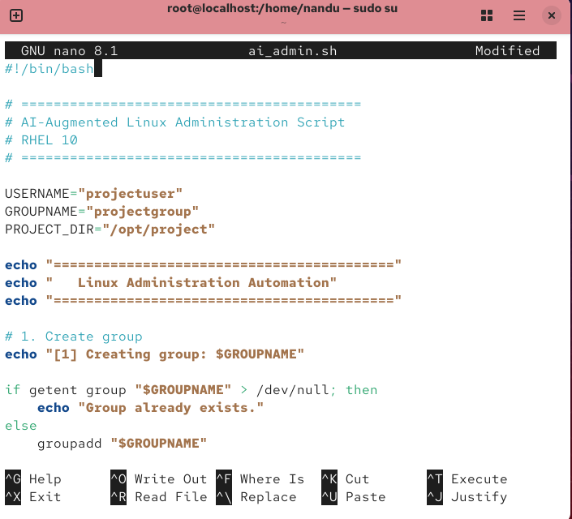

Give permission for that script and check the script

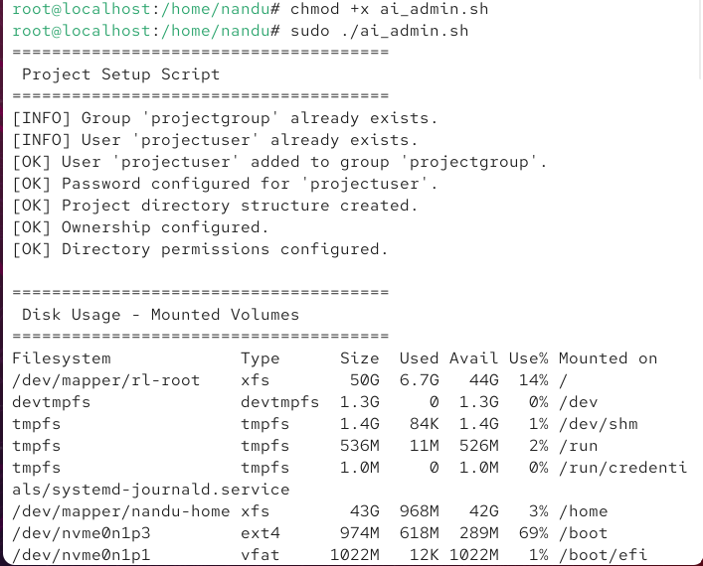

Here we can see the group have permission for read and execute but we have gone for all permission only for user

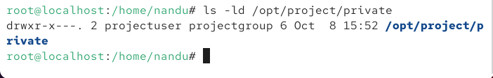

This is the solution of bug

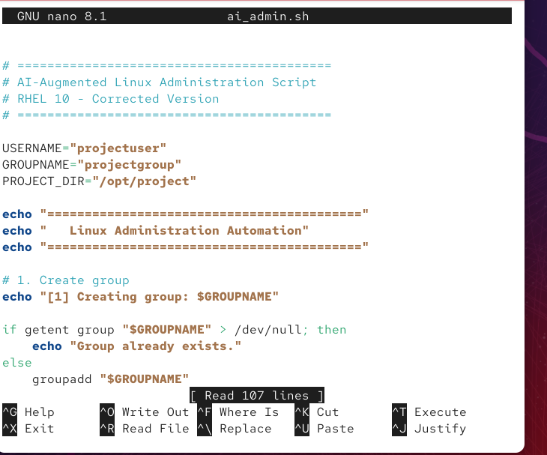

Now you can see all permission only for user. group and other don’t have any permission

